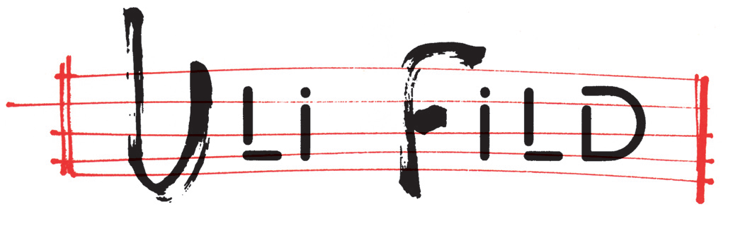

RAVA SPECIAL EDITION “ 80 years of Music”

Enrico RAVA trumpet & flugelhorn
Gianluca PETRELLA trombone
Francesco DIODATI guitar
Giovanni GUIDI piano
Gabriele EVANGELISTA bass
Enrico MORELLO drums

It has been more than 50 years since famed trumpeter Enrico Rava first appeared in the Italian and international jazz scenes. He had initially worked with artists such as Gato Barbieri and Steve Lacy, with whom he spent a brief period in Buenos Aires alongside South African musicians Johnny Dyani and Louis Moholo. He later moved to New York where he met and worked with artists such as Roswell Rudd, Carla Bley, John Abercrombie and Cecil Taylor.

During the mid-1970's, he returned to Italy and spent the next few decades leading various groups and producing numerous recordings. His return also sparked a fascination with the Opera, which subsequently influenced two of his albums Rava, L'Opera Va' and Carmen. Moreover, he ventured into the world of pop through his renditions of selected songs of Michael Jackson, paying an homage to the deceased King of Pop by producing the album On the dance floor.

He was famously inclined to work with young musicians, which generated the discoveries of artists such as Massimo Urbani, Paolo Fresu, Stefano Bollani, Gianluca Petrella, Giovanni Guidi and Francesco Diodati.

Throughout his extensive career, he has played alongside notable musicians such as Lee Konitz, Richard Galliano, Pat Metheny, John Scofield, Dave Douglas, Geri Allen, Cecil Taylor, Miroslav Vitous, Philip Caterine, Tomasz Stanko, Michel Petrucciani, John Abercrombie and Joe Lovano.

Now, at the dawn of his 80's, Rava has begun to envision a special project for which he has specifically composed new material in addition to revisiting his most significant work. Impatient audiences can expect performances in theaters worldwide within the next coming months. He will be accompanied by the following group of extraordinary musicians with whom he has most collaborated in recent years.

Giovanni Guidi is a revered pianist among the young Italian generation of jazz musicians. He gained substantial recognition early on in his career, when he won the Top Jazz 2007 (the critics prize announced by the magazine Musica Jazz) as best new national talent. His album “Ida Lupino” which he recorded with Gianluca Petrella also won best Italian record in 2016. He has produced more than ten records under his name which have all garnered favorable reviews by critics. Guidi is constantly seeking innovative solutions as an improviser, composer and bandleader which in turn has led him to participate in numerous national and international music festivals.

Gianluca Petrella hails as one of the most significant jazz trombonists in the world and perhaps one of the most renowned Italian jazz musicians of all time. His list of collaborations extensively include prominent musicians such as Steve Bernstein, Bobby Previte, Pat etheny, Tomasz Stanko, Greg Osby, Carla Bley ed italiani, Paolo Fresu, Roberto Gatto, Antonello Salis, Gianluigi Trovesi, Francesco Bearzatti, Danilo Rea and many others.

Francesco Diodati is a rapidly rising star in the "charts" among the new generation of musicians in the Italian and international jazz scenes. His vast knowledge and experimentation with electronic effects enabled him to expand the borders of electric and acoustic guitar techniques. Diodati continually shares his research among the contemporary jazz scene maintaining the possibility that history can live together with a more open conception of sound.

Gabriele Evangelista is a praised Italian bass player known for burning stages with his skills of extraordinary precision combined with a wild creativity and distinctive interplay. He is Rava’s most recent discovery, a talent who is currently being highly requested and sought after.

Enrico Morello emerged from a strong academic background and is widely known for his refined drumming style, his unique perception of dynamics and a remarkable swing. He has acquired a series of international experiences and continues to study the instrument with passion and profession. He is presently curious with preserving tradition while looking onto the future.

